**Project Report Template**

Tracing the growth of global community: A population forecasting analysis

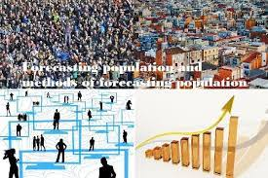

1. INTRODUCTION

1.1 Overview

The world’s population is more than three times larger than it was in the mid-twentieth century. The global human population reached 8.0 billion in mid-November 2022 from an estimated 2.5 billion people in 1950, adding 1 billion people since 2010 and 2 billion since 1998. The world’s population is expected to increase by nearly 2 billion persons in the next 30 years, from the current 8 billion to 9.7 billion in 2050 and could peak at nearly 10.4 billion in the mid-2080s.

This dramatic growth has been driven largely by increasing numbers of people surviving to reproductive age, the gradual increase in human lifespan, increasing urbanization, and accelerating migration. Major changes in fertility rate have accompanied this growth. These trends will have far-reaching implications for generations to come.

* 1. Purpose

A population projection gives a picture of what the future size and structure of the population by sex and age might look like. It is based on knowledge of the past trends, and for the future, on assumptions made for three components: fertility, morality and migration.

1. Problem Definition & Design Thinking

2.1 Empathy Map

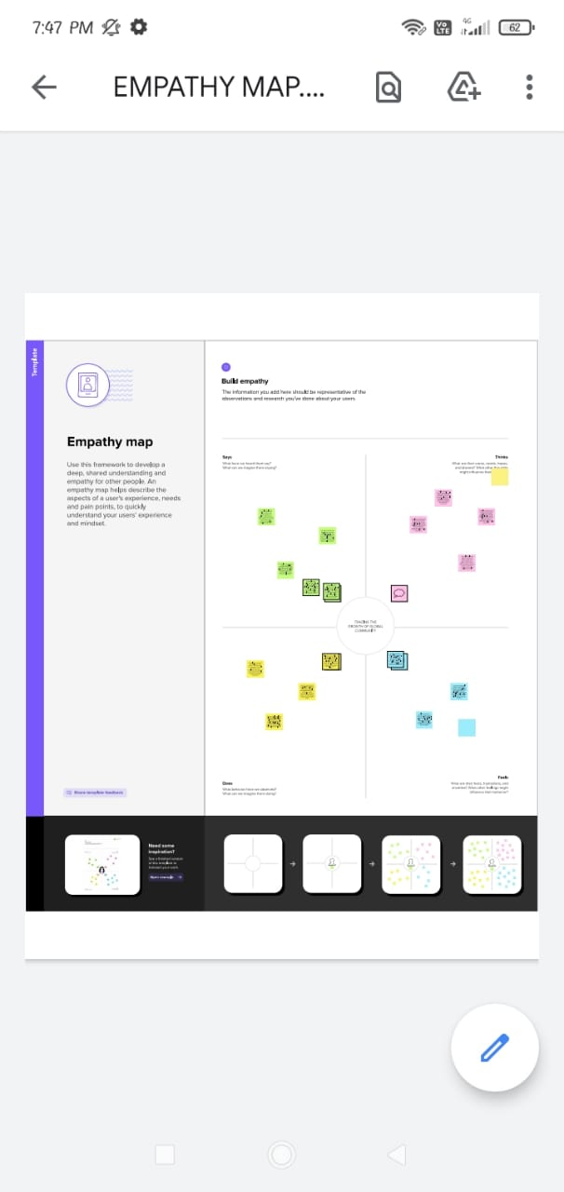

* 1. Ideation & Brainstorming Map

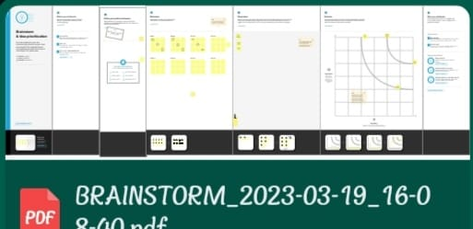

1. RESULT

DASHBOARD

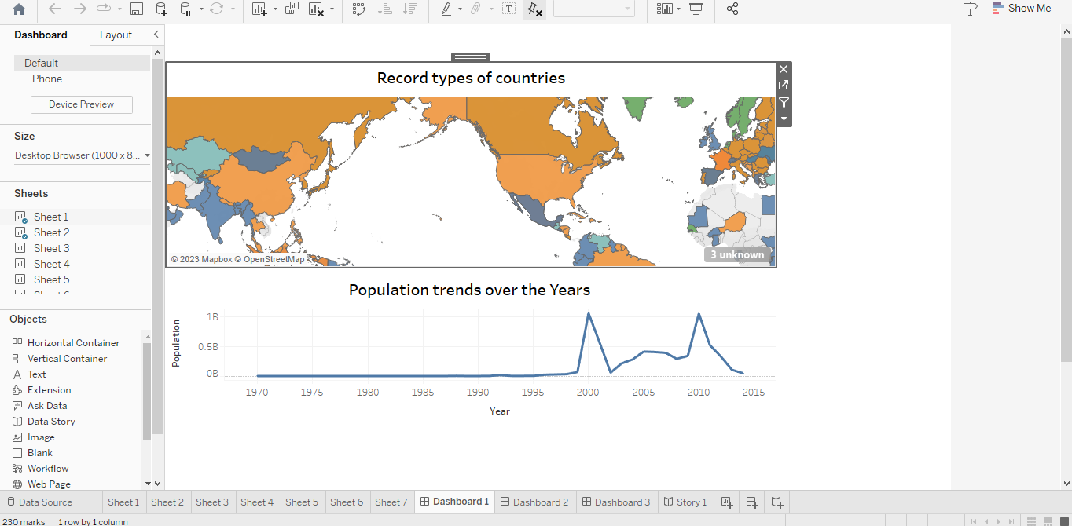

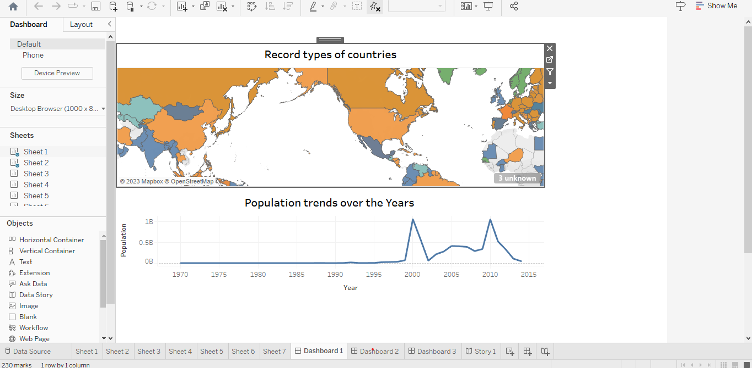

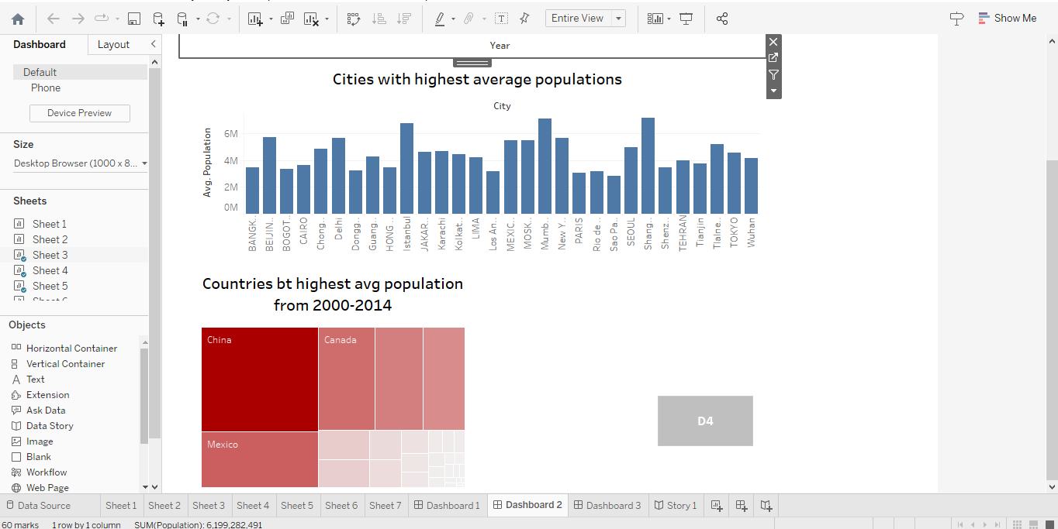

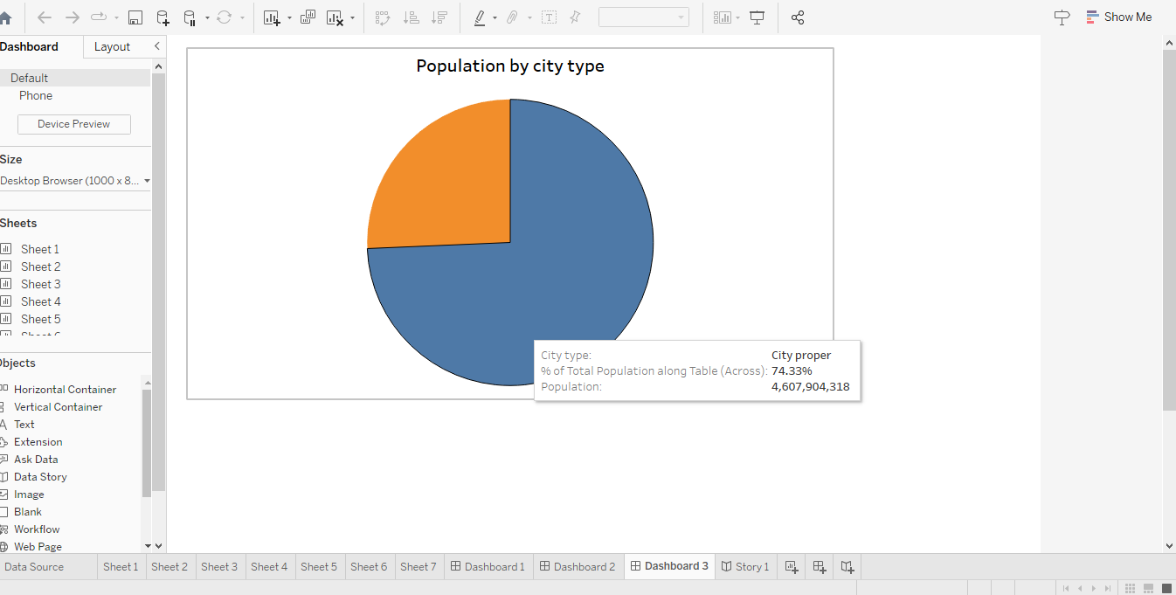

STORY

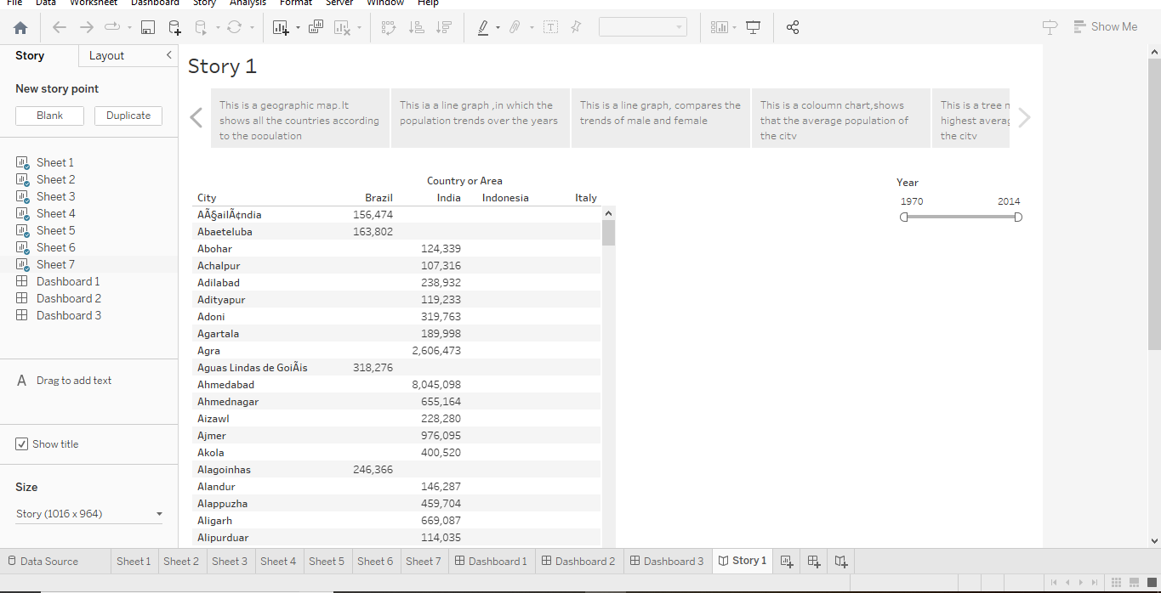

Web integration

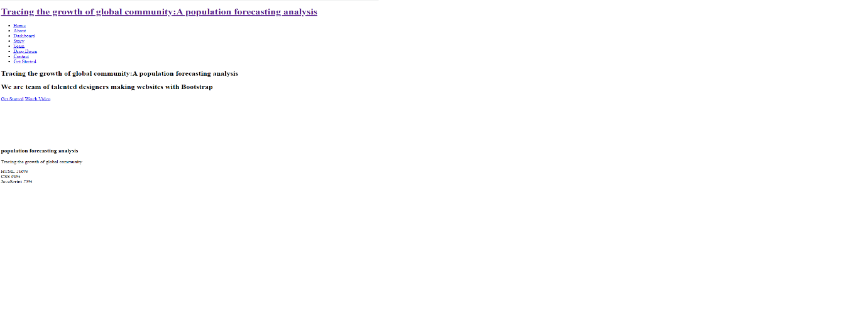

1. ADVANTAGES & DISADVANTAGES

Advantages:

* **Human Resources will Increase.**
* **Increased productivity through specialization**
* **Demand has led to more jobs.**
* **Greater economic growth**
* **Rapid population decreases Social Infrastructure**
* **Higher population density efficiency**
* **Diversity fosters creativity**
* **Improved societal demographic structure**
* **Higher Industry Demand**
* **Increasing military power**

**Disadvantages:**

* **Increasing Resources Demand**
* **Shortage of food due to population expansion**
* **Generating Non-biodegradable waste**.
* **Increase Pollution**
* **Disturbance in Emergency Situation**
* **Threat to Natural Habitat**
* **Infections Outbreaks**
* **Effect on climate**
* **Water Shortage**
* **Capital production declines as the population grow**

5.APPLICATIONS

INDIA:

The current population of India is 1,417,533,374 as of Tuesday, April 11, 2023, based on Worldometer elaboration of the latest United Nations data. India 2020 population is estimated at 1,380,004,385 people at mid year according to UN data.

AMERICA:

The current population of the United States of America is 336,369,717 as of Tuesday, April 11, 2023, based on Worldometer elaboration of the latest United Nations data.

KARNATAKA:

Karnataka population in 2023 is estimated to be 67.6 Million (6.76 Crores), By March 2022 Karnataka population is projected to be 6.72 crores as per Unique Identification Aadhar India, updated 31, March 2022. Its area is 191,791 sq km and ranks 8th largest in India, with the land area 5.83% of coverage

6.CONCLUSION

Summary measures of population health that integrate mortality and morbidity information are increasingly relevant to both public health and medical decisionmakers.

7.FUTURE SCOPE

Scopes of population geography:

Variation in population density due to environmental or geographical condition. The demographic phenomenon like mortality, growth rate, birth rate, etc. is studied. Increase or decrease in population numbers in a place.

**A quantitative study of human distribution in a particular area or space**. Variation in population density due to environmental or geographical condition. The demographic phenomenon like mortality, growth rate, birth rate, etc. is studied.

8.APPENDIX

C:/Users/ELCOT/Downloads/Arsha/Arsha/index.html